**JAVA PROGAMMING LIST**

1. Write a Program to find greatest of three numbers using Ternary Operator.
2. Write a Program to display Hello world.
3. WAP to accept two no.s and display the sum.
4. Write a Program to read a floating point number and print Integer and Float part of the number separately.
5. Write a Program to calculate displacement using formulae s=ut+1/2at2 given values of a,u,t by the user
6. Write a Program to check weather a number is Even or Odd
7. Write a Program to print table of a number
8. Write a Program to print factorial of a number
9. Write a Program to print the following Pattern

5 5 5 5 5

4 4 4 4

3 3 3

2 2

1

1. Write a Program to print the following Pattern

1

1 2

1 2 3

1 2 3 4

1. Write a Program to swap two numbers without using the third variable
2. Write a Program to check weather a string is Palindrome or not
3. Write a Program to calculate sum and sum of squares of first 15 Even Numbers
4. Write a Program to check weather a number is prime or not
5. Write a Program to convert Binary Number to Decimal Number
6. Write a Program to check weather a number is Armstrong or not.
7. Write a Program to calculate Simple Interest using the concept of classes
8. Write a Program to illustrate the concept of Static Member Data and Static Member Function
9. Write a Program to make a Simple Calculator using the concept of classes
10. Write a Menu Driven Program to Add, Subtract, Multiply two matrices of order 2X2 using concepts of Object Oriented Programming.
11. Write a Program to swap two integer values, two floating point values, two character values using function overloading
12. WAP that creates a class Accounts with following details:Instance variables: ac_no., name, ac_name, balance .Methods: withdrawal(), deposit(),display().Use constructors to initialize members.
13. WAP to implement constructor overloading.
14. WAP to count the no. of objects created in a program.
15. WAP to show call by value & call by reference.
16. WAP to implement method over ridding & method overloading.
17. WAP that demonstrates all the usages of “super” keyword.
18. Create a class box having height, width , depth as the instance variables & calculate its volume. Implement constructor overloading in it. Create a subclass named box_new that has weight as an instance variable. Use super in the box_new class to initialize members of the base class.
19. WAP that implements multilevel inheritance.
20. Identify the type of inheritance and implement it by modelling the Examination Database

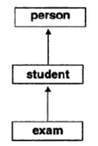

1. Which type of inheritance is this? Illustrate this inheritance by writing a program assuming your own data members.

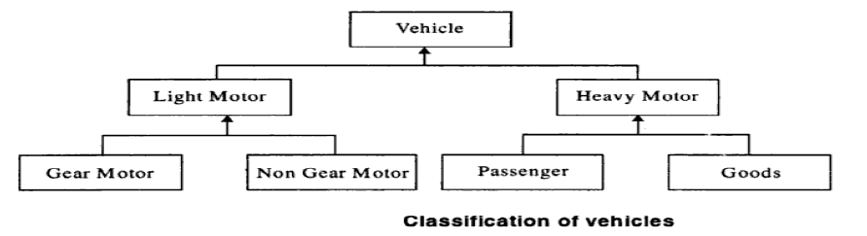

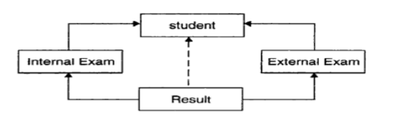

1. Consider a university where students who participate in the national games or Olympics are given some grace marks. Therefore, the final marks awarded = Exam_Marks + Sports_Grace_Marks. A class diagram representing this scenario is as follow;

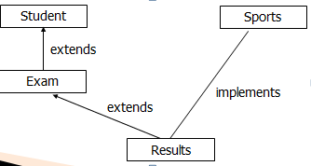

1. WAP to implement Run time polymorphism.
2. WAP to implement interface. Create an interface named Shape having area() & perimeter() as its methods. Create three classes circle, rectangle & square that implement this interface.
3. WAP to show multiple inheritance.
4. **WAP to implement exception handling. The program should accept two numbers from the user & divide the first no. by the second. It should throw a Arithmetic Exception if an attempt is made to divide the no. by zero. Use try, catch & finally .Implement multi-catch statements** also .
5. Create a user defined exception named “NoMatchException” that is fired when the number entered by the user is not 10.Use the throws & throw keyword.
6. WAP that creates three threads which print no.s from 1 to 5, 6 to 10 and 11 to 15 respectively .Set the name & priority of the threads.
7. WAP to print even & odd numbers using threads.
8. WAP that implements the concept of synchronization in threads using both syncronized method and synchronized block.
9. WAP that demonstrates the use of sleep and join methods in thread. Use minimum three threads.
10. WAP to demonstrate the use of equals(), trim() ,length() , substring(), compareTo() of String class.
11. WAP to implement file handling . The program should copy the content from one file to another.